**Spinsim GSL Simulator Tutorial**

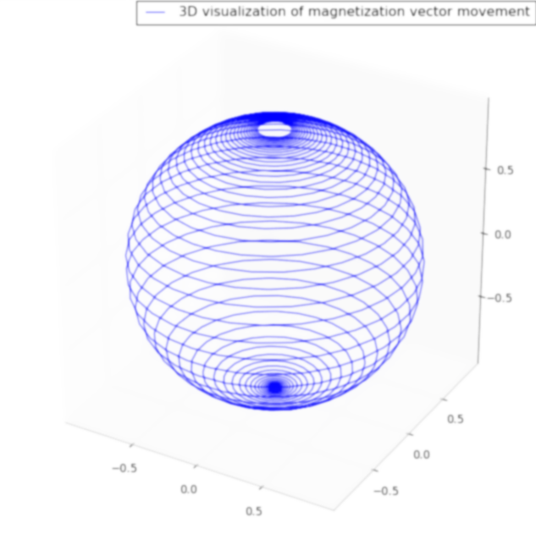

**Revision 0.1  
Written 2011-04-04 I. Yulaev  
Center for Magnetic Recording Research  
University of California, San Diego**

# Table of Contents

0 Table of Contents 2

0.1 Table of Figures 2

0.2 Table of Equations **Error! Bookmark not defined.**

1 Overview 3

1.1 Licensing Terms 3

1.2 Change Log 3

1.3 Terminology 3

1.4 Simulation Accuracy 4

1.5 Useful References 4

1.6 Contact 4

2 Installation and Compilation of Spinsim GSL 5

2.1 Installing Linux 5

2.2 Downloading Required Packages 5

3 Compiling and Running Spinsim GSL 7

3.1 Compilation 7

3.2 Opening the Spinsim GUI 8

3.3 Single-Point Time-Domain Simulations 11

3.4 H and J Hysteresis loops 12

## Table of Figures

Figure 1 - Screenshot of the Synaptic Package Manager 6

Figure 2 - Screenshot of Selecting the "Open in Terminal" Menu Option 7

Figure 3 - Screenshot of the Compilation Process 8

Figure 4 - Screenshot of Spinsim GUI Running 9

Figure 5 - Hitting 'OK' to run the simulator 9

Figure 6 - Selecting the Plot Type and Making the Plot 10

Figure 7 - Screenshot of the Plot you should see 10

Figure 8 - Selecting the 'Single Plot' Menu Item 11

Figure 9 - Single Point Plot you should see 12

Figure 10 - Screenshot of Appropriate Hysteresis Loop Parameters 12

Figure 11 - Screenshot of H-field Hysteresis Loop 13

# Overview

Spinsim GSL is a macromagnetic simulator of multi-layered nano-magnetic thin film structures. It is geared towards simulation of the behavior of thin film magnetization under stimulus from perpendicularly-applied currents and fields. It is particularly suited for simulation of magnetization dynamics due to spin torque transfer, as modeled by the Landau Lifshitz Gilbert equations with the Slonczewski Spin Torque Transfer term. One or two free layers, plus an optional fixed layer, can be simulated; inter-layer interaction in the form of mutual demagnetizing field and exchange coupling can be simulated. A GUI is provided for setting up all of the relevant parameters for the model. Plotting of results is supported.

This program was developed chiefly by Ivan Yulaev, a former undergraduate student at UCSD, working under the direction of Professor Eric Fullerton of the UCSD Center for Magnetic Recording Research. Stephanie Moyerman assisted greatly with the underlying mathematics, as well as writing the initial drafts of the code.

This document provides a brief tutorial that demonstrates how to use Spinsim GSL to simulate the behavior of common nanomagnetic models. The goal is to familiarize the user with the commonly used features of Spinsim GSL. For a much more thorough look at how Spinsim GSL operates and a more extensive description of the features it has, please see the User Manual, which is distributed with the Spinsim GSL Package.

## Licensing Terms

Spinsim GSL is distributed under the GNU General Public License License. The program is property of the CMRR at the University of California.

No warrantee of fitness or performance is expressed or implied. Use at your own risk.

A full text of the license may be found at <http://www.gnu.org/copyleft/gpl.html>.

## Change Log

This section describes the change history for this manual.

**Revision 0.1 – 2010-04-04**Initial revision

## Terminology

Some terms in this document are used interchangably, and thus require disambiguation.

The terms “Spinsim” and “Spinsim GSL” both reference the same project, namely, this project.

“Iteration” is used to refer to a time-independent current and applied field value pair, with which the magnetization of the structure is calculated. Typically, the spinsim simulator output will consist of the final magnetization of a layer for a grid of applied current/applied field pairs. Each point on the grid is an “iteration”.

## Simulation Accuracy

Spinsim GSL was developed to allow for very rapid simulation of magnetization behavior and thus efficient exploration of parameter space for magnetic thin films. It sacrifices accuracy in exchange for very fast run times. Commercial micromagnetic simulations can often provide greater accuracy of results at the expense of long run times. Part of the Spinsim GSL development process was correlation of simulation results to “known good” micromagnetic simulators. More specifically, for numerous common models, results from the Spinsim GSL simulator, particularly the measured critical switching current for a free layer, were compared to commercial micromagnetic simulation results. It was found that for most of the models, the Spinsim GSL simulations determined IC to within 10% of the value measured by a micromagnetic simulator.

As for all simulation tools, it is important to run many simulations on known models before using the simulator to explore new areas. Simulation tools cannot take into account real-world imperfections in magnetic materials, which can cause simulation results to deviate significantly from those measured empirically. *The creators of Spinsim GSL neither claim nor imply any warranties regarding the fitness or performance on the Spinsim GSL simulator. The simulator is provided “as is”.*

## Useful References

The README file, located in the “doc/” sub-directory of the project, contains some instructions and technical details.

The Landau-Lifshitz-Gilbert equation is the core of the computation done by the Spinsim GSL simulator. In essence, the function of the simulator is to set up the model as a magnetized layer and set of effective magnetic fields, and then model the behavior of the layer by integrating the LLG equation repeatedly. Wikipedia provides [a brief overview of this equation](http://en.wikipedia.org/wiki/Landau%E2%80%93Lifshitz%E2%80%93Gilbert_equation).

Massimiliano d’Aquino’s Thesis “Nonlinear Magnetization Dynamics in Thim-Films and Nanoparticles” provides a great introduction to the general topic Spinsim GSL operates within. His thesis may be found online at <http://wpage.unina.it/mdaquino/PhD_thesis/main/main.html>.

For a general discussion of spin torque transfer effects, Xiao, Zangwill, and Stiles provides a great overview in “Macrospin models of spin transfer dynamics” (Physical Rev. B **72**, 014446 (2005)).

Throughout this tutorial, other references regarding specific parts of Spinsim GSL are provided as relevant.

## Contact

For questions or comments regarding the program, contact Ivan Yulaev (ivan_yulaev@yahoo.com).

# Installation and Compilation of Spinsim GSL

## Installing Linux

This tutorial assumes that the user has already installed the Linux operating system. Spinsim GSL is tested only under Linux. If the user has not installed Linux, it is recommended that (s)he install the operating system. It is also possible to install Linux as a virtual machine, so that it may be run from within the Windows OS. This is possible through tools such as Sun/Oracle VirtualBox.

The recommended Linux distributions for running Spinsim GSL are Ubuntu, Linux Mint, and Debian. Ubuntu is highly recommended for users unfamiliar with the Linux operating system.

The installation of the linux OS is outside of the scope of this tutorial. An excellent tutorial on installing Ubuntu is available at <https://help.ubuntu.com/community/Installation>.

A tutorial on installing Linux as a Virtual Machine, so that it can be run from within Windows, is available at <http://www.psychocats.net/ubuntu/virtualbox>.

## Downloading Required Packages

Once linux is installed, some more packages must be installed before Spinsim GSL can be compiled and run. These are:

* gsl-bin
* python-qt4
* python-matplotlib
* python-qt4-dev
* libgsl0-dev
* libgsl0ldbl
* pyqt4-dev-tools
* qt4-designer
* libpng12-dev
* libpng12-0

These packages can be installed using the Synaptic Package Manager. Use the search bar to find each package; once it is found, right-click and select “mark for installation”.

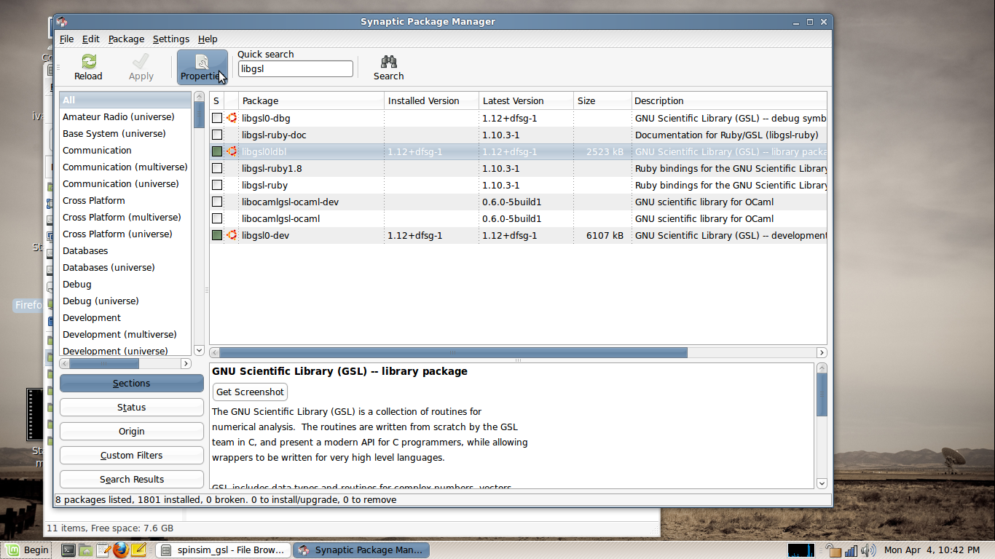

Figure 1 - Screenshot of the Synaptic Package Manager

Once all of the packages have been marked, click the Apply button. Synaptic will prompt you again to confirm your choice; hit “apply” once again and the packages will be installed. This may take some time, particularly on a slow machine with a slow internet connection

# Compiling and Running Spinsim GSL

## Compilation

At this point, your system is set up with the proper pacakges to compile Spinsim GSL. Download the latest Spinsim GSL package from

<http://ivanmegan.crabdance.com/~ivany/spinsim_pub/spinsim_gsl_release.zip>

Un-zip this archive into your Linux home folder. Open a terminal by browsing to this folder, right-clicking somewhere in the window, and selecting ‘open in terminal’.

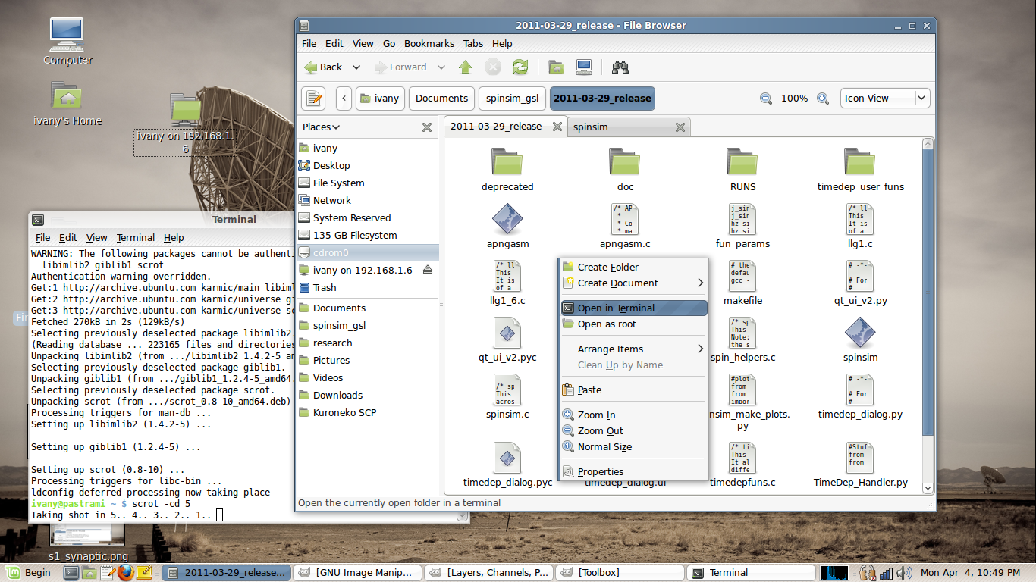

Figure 2 - Screenshot of Selecting the "Open in Terminal" Menu Option

A terminal window should open; in this window, type “make all”. A few lines should appear in the terminal indicating the status. If you see Error or Warning, then most likely you are doing something wrong.

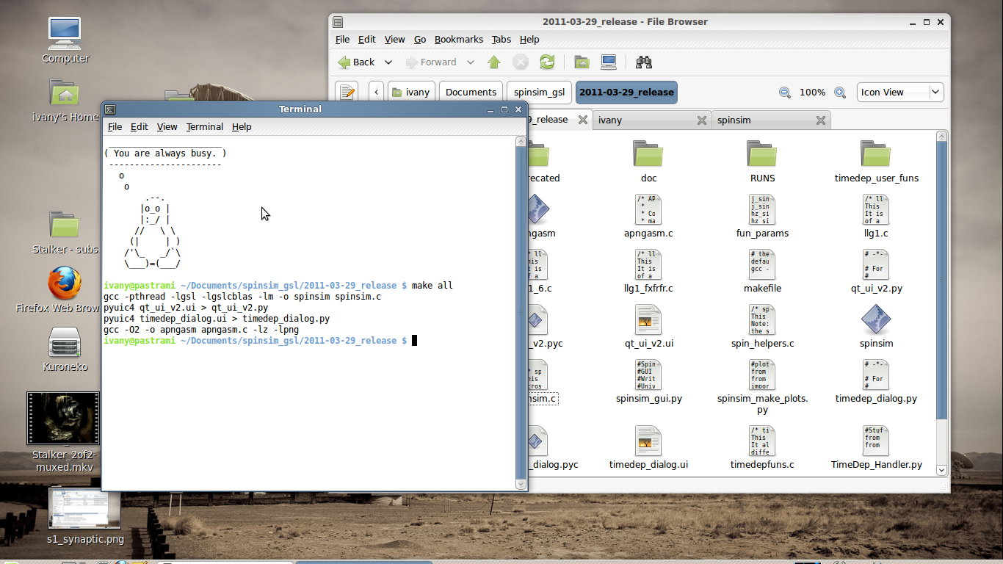

Figure 3 - Screenshot of the Compilation Process

At this point, you should be ready to run Spinsim GSL!

## Opening the Spinsim GUI

In the same terminal window in which the compilation was done, type “python spinsim_gui.py”. The Spinsim GSL graphical interface should appear.

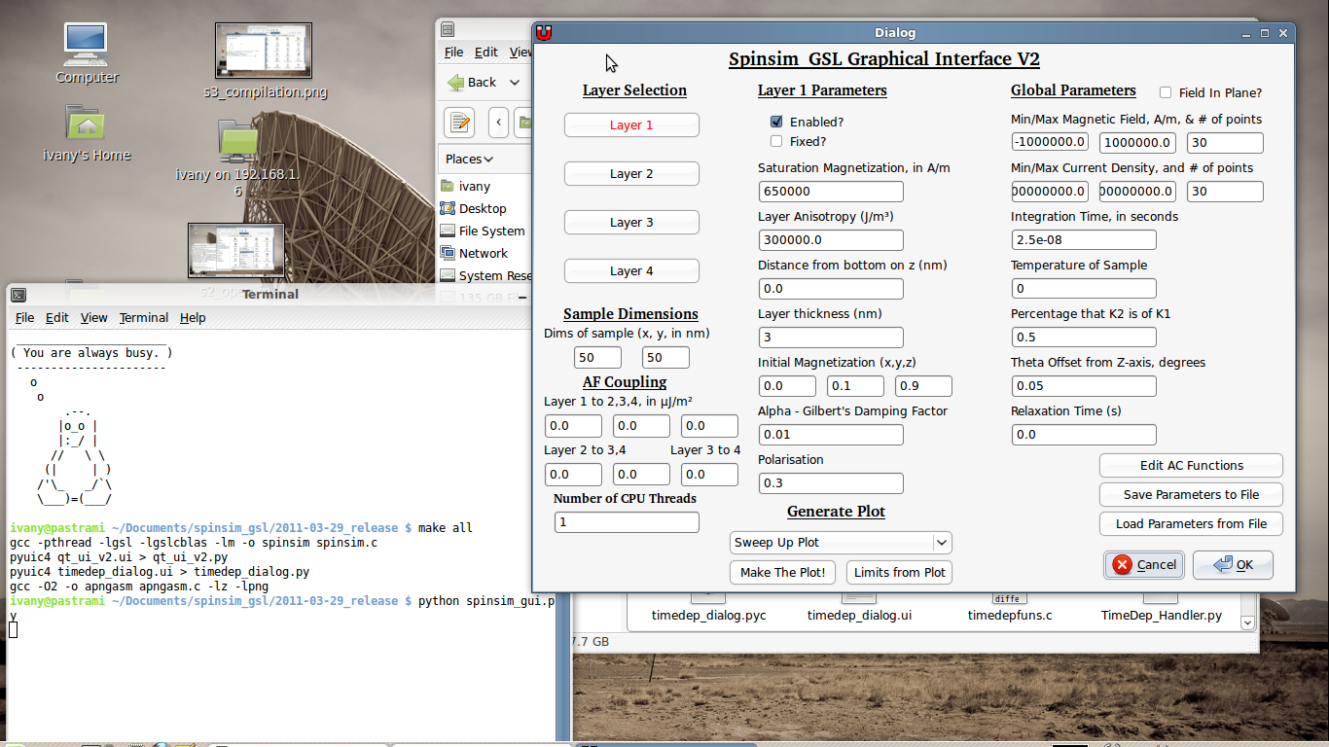

Figure 4 - Screenshot of Spinsim GUI Running

Let’s simulate the default problem loaded into Spinsim GSL. This will simulate a phase plot of an array of 30 by 30 field-current condition points, for a 2-layer macrospin model. In the GUI, hit the OK button in the bottom-right of the screen to begin the simulation. A progress bar should appear in the bottom-left of the GUI, indicating the run progress. When this reaches 100%, let’s generate a plot.

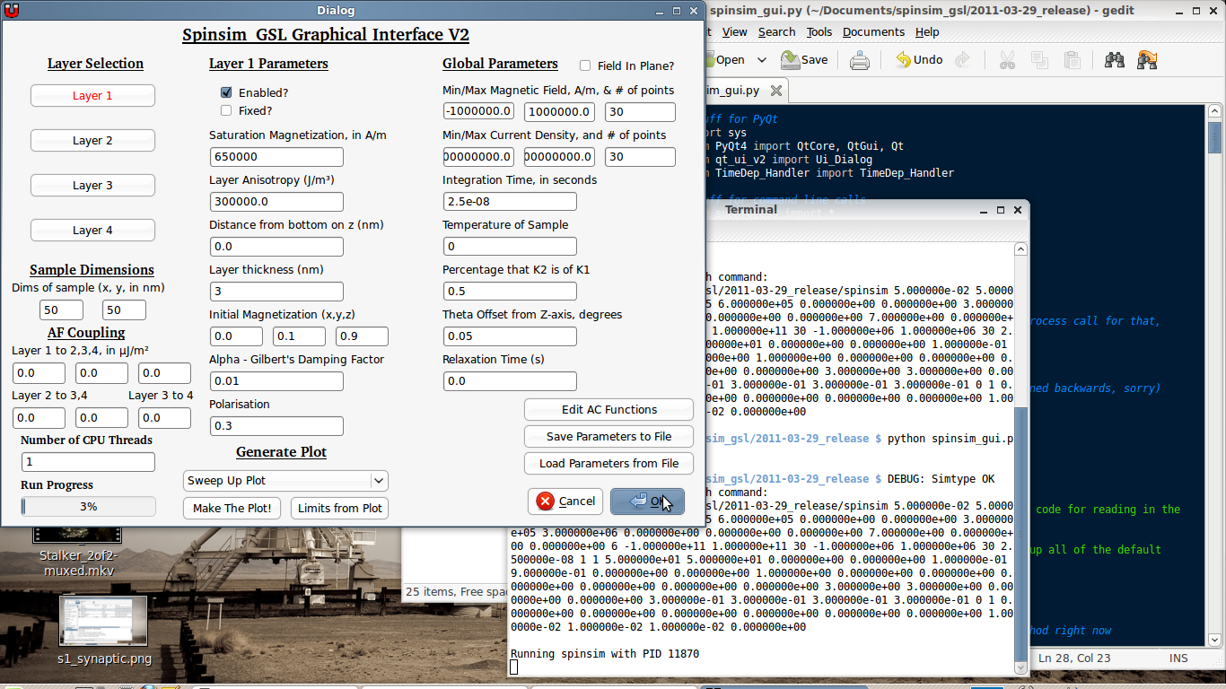

Figure 5 - Hitting 'OK' to run the simulator

Select the “All Plots” option under the Generate Plot drop-down menu. Hit “make plot”; this should generate a plot as below:

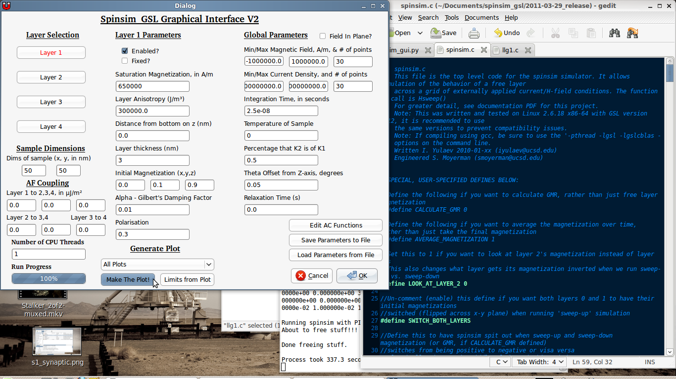

Figure 6 - Selecting the Plot Type and Making the Plot

Watch the terminal window for any possible error messages; if there are still missing dependencies the program will indicate so in the terminal.

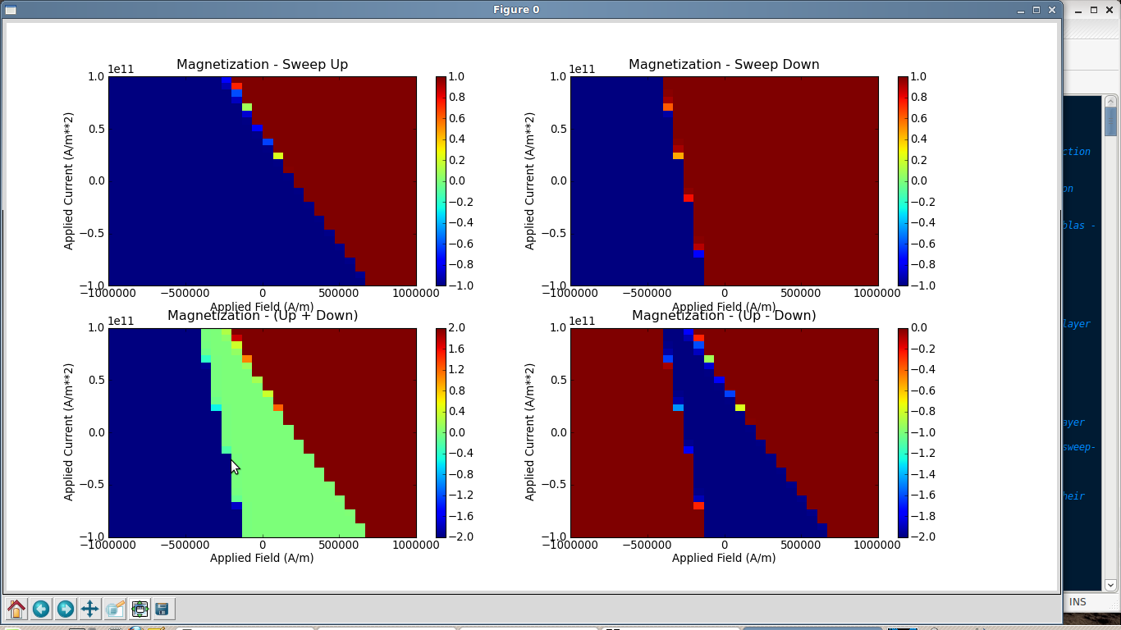

Figure 7 - Screenshot of the Plot you should see

## Single-Point Time-Domain Simulations

It is possible to simulate and display the time-domain behavior of the free layer’s magnetization, for a single field-current condition. Let’s try setting the field to -1 x 106 A/m, and the current to 0. We do this by setting both the min and the max values of field / current to the same value, and setting the point densities to 1.

We then run the simulation; this simulation should run very quickly. Now, select “single plot” under the Generate Plot dropdown menu. A time-domain representation, as well as a 3D “illustrative” plot should appear as below. This plot can be zoomed in and moved by using the plot navigation buttons in the lower-left corner of the plot window.

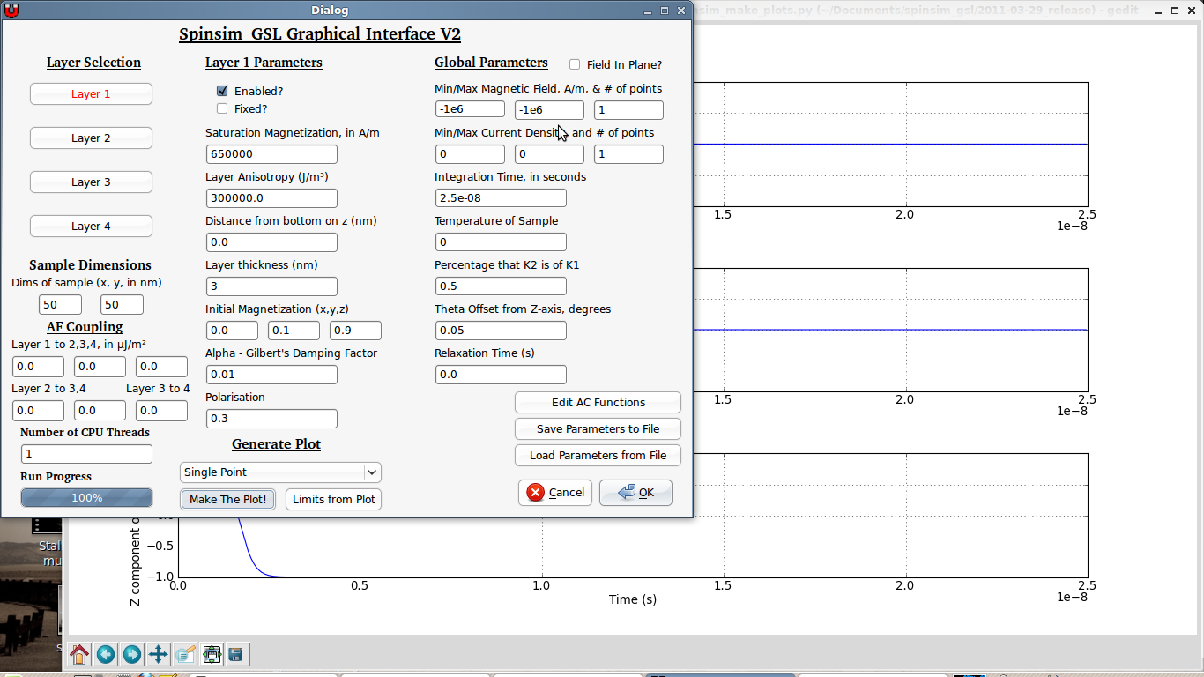

Figure 8 - Selecting the 'Single Plot' Menu Item

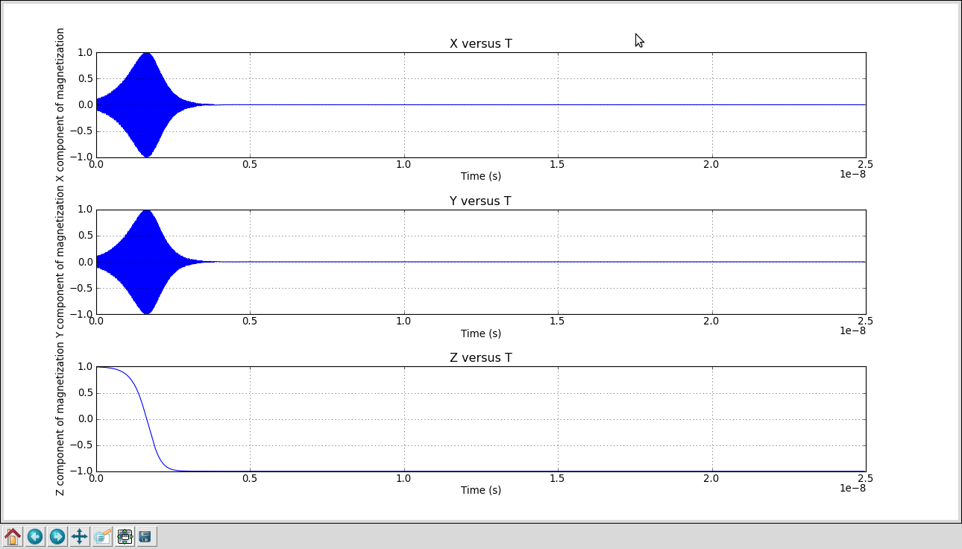

Figure 9 - Single Point Plot you should see

## H and J Hysteresis loops

Now, we’ll give an example of running a H-field hysteresis loop. Change the max magnetic field to 1e6, and set the point density to 100.

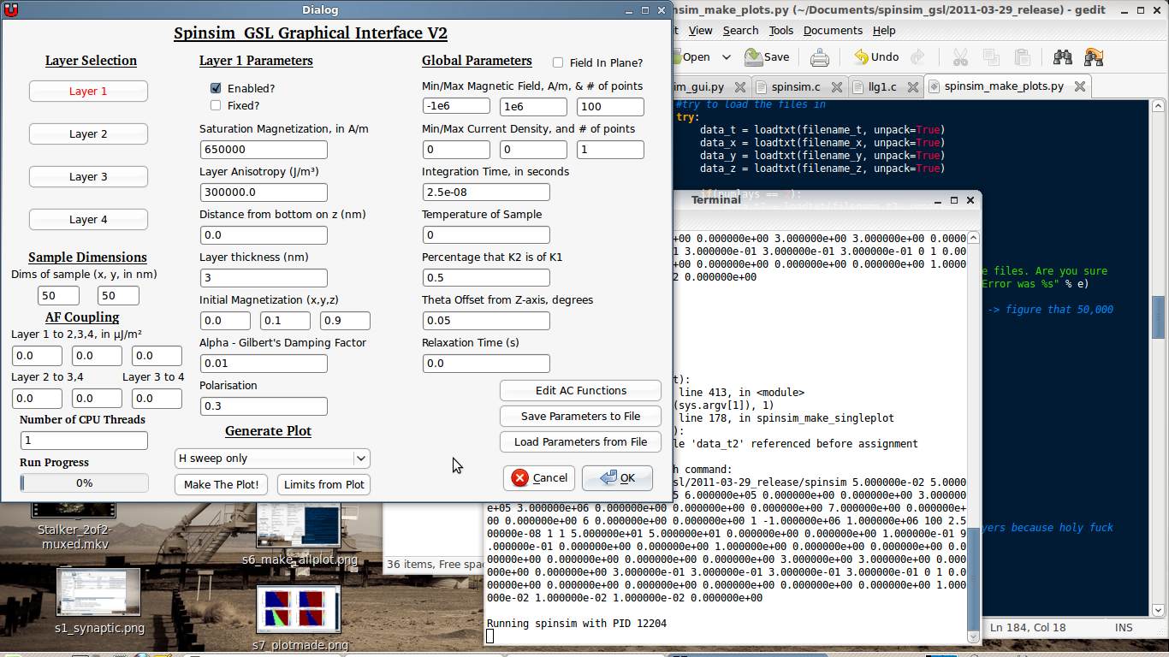

Figure 10 - Screenshot of Appropriate Hysteresis Loop Parameters

Hit OK once again to run the simulation, and generate the plot for type “H sweep only”. You should see the figure as below:

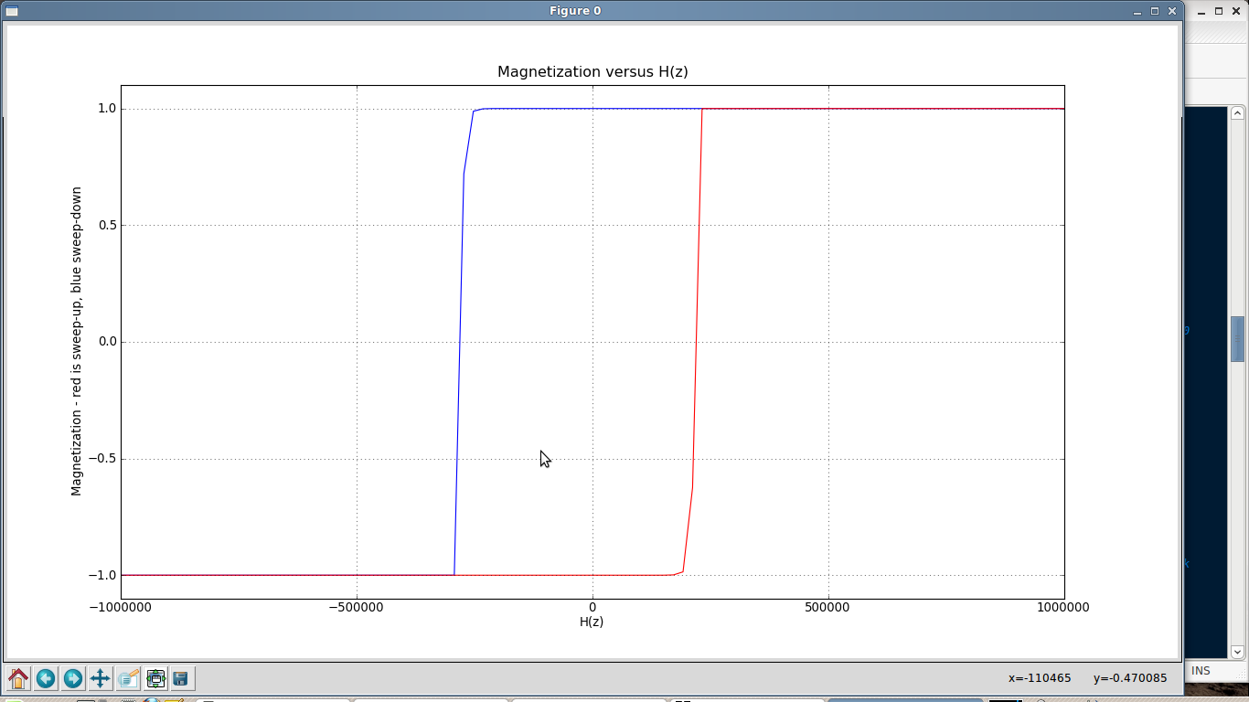Figure 11 - Screenshot of H-field Hysteresis Loop

# Conclusion

This concludes our tutorial on using the Spinsim GSL simulator. The Spinsim GSL macrospin simulator is a fast, light-weight simulation tool for exploring the behavior of nano-scale magnetic elements. Due to the high simulation speed (as compared to a micromagnetic simulator), Spinsim GSL allows for rapid exploration of parameter space. Many more options are available in the simulator than are described in this tutorial; please see the User Manual for a detailed description of all of the features on Spinsim GSL.

## Feedback

Feedback on this tutorial (and the Spinsim GSL simulator itself) is appreciated. If you would like to see a particular problem added to this tutorial, contact Ivan at ivan_yulaev@yahoo.com.